**Site Purpose**:

Provide a brief statement about the purpose of the website drawing upon the client's functional specifications, the industry, and any fictitious but viable goals that you deem to be reasonable.

This website is to provide a great source for the chamber of commerce as well as potential members, and partners. This site will provide a form to apply for membership. It will also promote the local businesses and advocate for the area.

**Target Audience**:

Research who the website visitors will be by discovering the industry, visiting similar sites and asking your friends, family or acquaintances through an informal survey about the industry. You may elect to develop [personas (Links to an external site.)](https://www.usability.gov/how-to-and-tools/methods/personas.html) for the distinct type of site visitors. This section should describe the target audience being judicious about the selection of the most plausible demographics.

**The target audience for this site are business owners, potential Chamber members, members of the community and potential new members of the community and business owners who may be looking to move to the area.**

Site Map:

The site map is a sketch of all the website pages and references. It should illustrate the relationship between those pages.



Color Scheme:

The color scheme refers to the carefully selected site colors that reflect the organization's purpose and trademark colors. Note the organization does not have established colors for brand identity. The planning document defines the color scheme through a color palette that labels color style definitions and swatches for site elements.

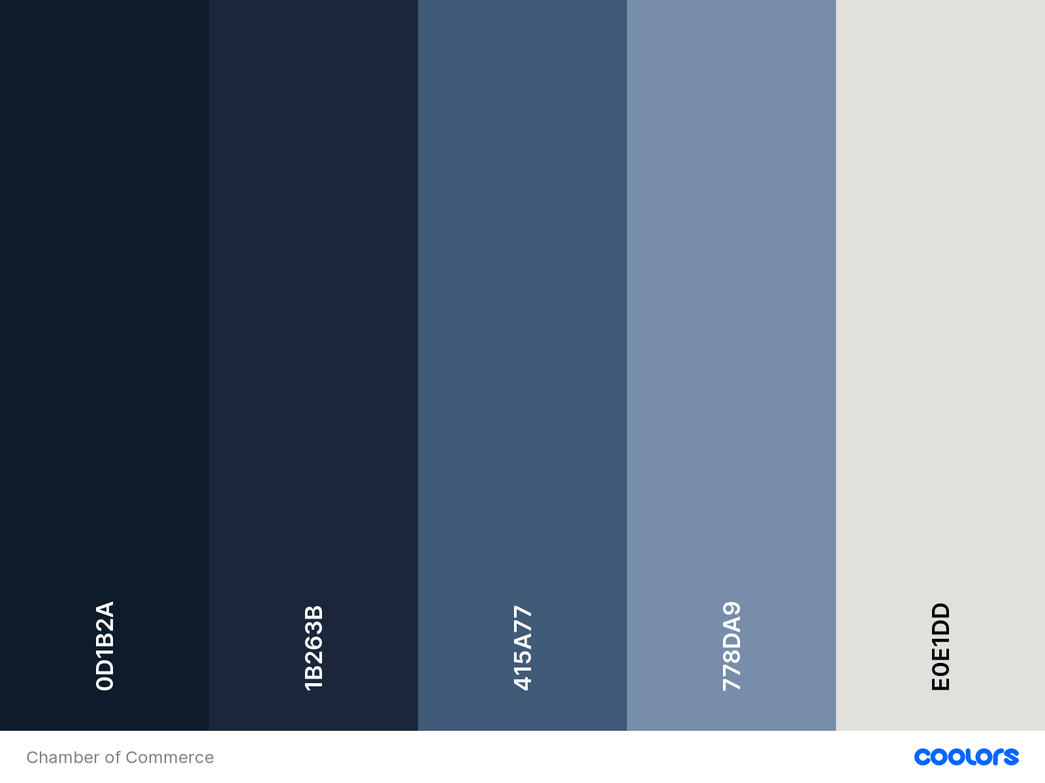

|  |  |  |  |  |
| --- | --- | --- | --- | --- |
| **Extra little touches** | **Header and nav backgrounds** | **Heading colors** | **Section Backgrounds** | **Section backgrounds/**  **font on color background** |

Typography:

The project specifications require that you utilize the directory of open source designer web fonts provided by Google Fonts. The typography section of the planning document provides examples of the fonts to be used and where they are to be applied.

* <link rel="preconnect" href="https://fonts.googleapis.com">
* <link rel="preconnect" href="https://fonts.gstatic.com" crossorigin>
* <link href="https://fonts.googleapis.com/css2?family=Murecho:wght@300&family=Playfair+Display:wght@400;500;600;700;800&display=swap" rel="stylesheet">

font-family: 'Murecho', sans-serif;

font-family: 'Playfair Display', serif;

I will be using the Playfair Display font for my headings. This is a more traditional serif font. I chose this for my headers because it is modern and nice looking, but also not too edgy or modern so the site still looks good.

I am using the Murecho font because it is a sans-serif font and is slightly easier to read. It is also sleek and subtle but still modern looking.

Wireframe Sketches:

Produce wireframe sketches of at least the home page of the site design considering the purpose, specifications, and target audience. You should include sketches for small, medium, and large views respectively meaning smart phones, tablets, and large width monitors.

